**VAISHALI BOKADIYA**

**DAY 2 ASSESSMENT**

**READING CSV & LAMBDA FUNCTION**

**File I/O using Python:**

**Read Data from CSV File into Python List:**

There are four ways of reading data from CSV in Python:

* Read CSV file using csv.reader()
* Read CSV file using .readlines() function
* Read CSV file using Pandas
* Read CSV file using csv.DictReader()

Let’s discuss each way in brief:

* Read CSV file using csv.reader()

Code:

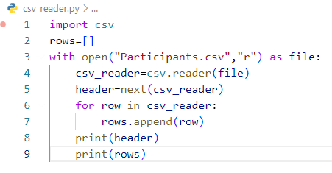

Output:

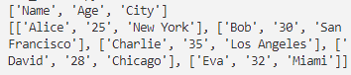

* Read CSV file using .readlines() function

Code:

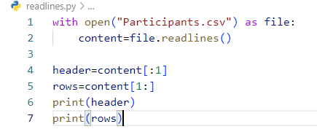

Output:

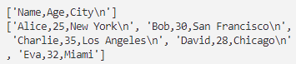

* Read CSV file using Pandas

Code:

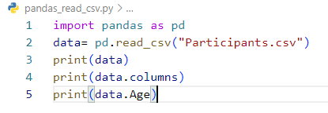

Output:

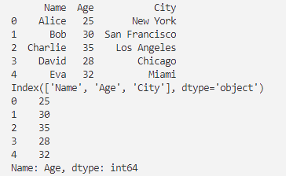

* Read CSV file using csv.DictReader()

Code:

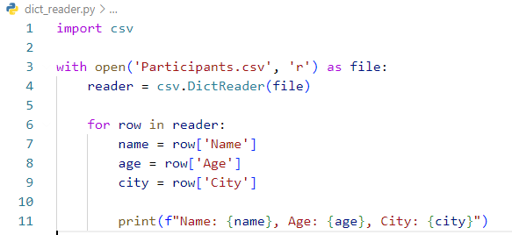

Output:

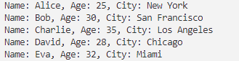

**Processing Python Lists:**

A list is a built-in data type that represents an ordered collection of elements. Lists are mutable, meaning you can modify their contents by adding, removing, or changing elements.

Features of List:

* Lists are ordered.
* Lists are heterogeneous.
* Lists are mutable.

Code:

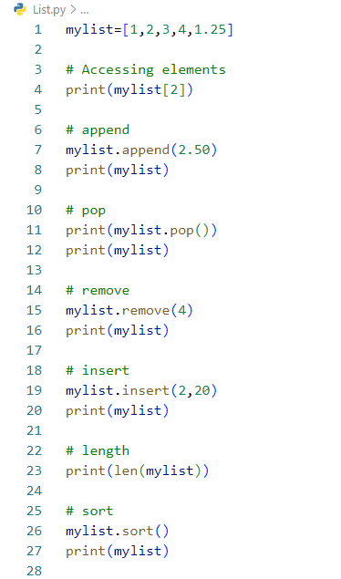

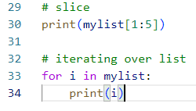

Output:

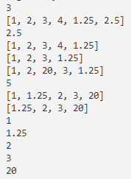

**Lambda Functions in Python:**

Lambda functions (also known as anonymous functions or lambda expressions) in Python are often used in situations where a small, one-time function is needed for a short duration.

Code:

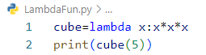

Output:



**Filter Data in Python Lists using filter and lambda:**

1. **Use of Lambda Function in Python**

Lambda functions can be used as arguments to higher-order functions like map(), filter(), and sorted().

1. **Practical Uses of Python lambda function**

* **Map, Filter, and Reduce:** Lambda functions are commonly used with functions like map(), filter(), and reduce().
* **Sorting:** Lambda functions can be used as the key parameter in sorting functions to customize the sorting criteria.
* **Conditional Expressions:** Lambda functions are useful for creating short conditional expressions.

1. **Using Lambda Function with map(), filter(), and reduce().**

Code:

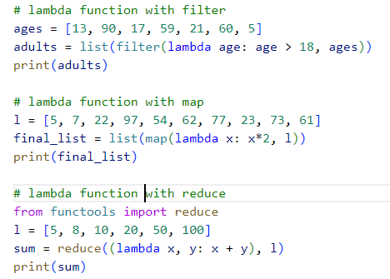

Output:

